Synod on Synodality Listening Sessions
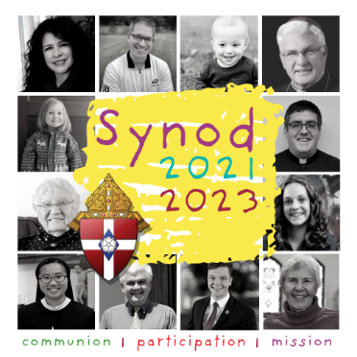
The Synod on Synodality is a two-year process of listening and dialogue that will conclude in 2023. Pope Francis has asked the entire Church to take an active part in the synod, inviting people from all walks of life and from all around the world to gather together for prayer, sharing experiences, listening, and seeking the guidance and wisdom of the Holy Spirit. Our parish’s listening session will be on (insert listening session information here). For more information, visit https://www.dowr.org/synod/index.html.

